|  |  |
| --- | --- |
|  | Faculty of Information Science and Technology  Universiti Kebangsaan Malaysia  43600 Bangi Selangor |
| **TTTK2103**  **Computer Network Technology** | |

**PACKET TRACER**

3.5.5 Packet Tracer - Investigate the TCP-IP and OSI Models in Action

|  |  |
| --- | --- |
| **Name** | **Matrix Number** |
| Mariam binti Masuan | A182976 |
| Mohamad Saiful Nizam bin Abd Aziz | A179830 |

**3.5.5 Packet Tracer - Investigate the TCP-IP and OSI Models in Action**

**Part 1: Examine HTTP Web Traffic**

**Step 1: Switch from Realtime to Simulation mode.**

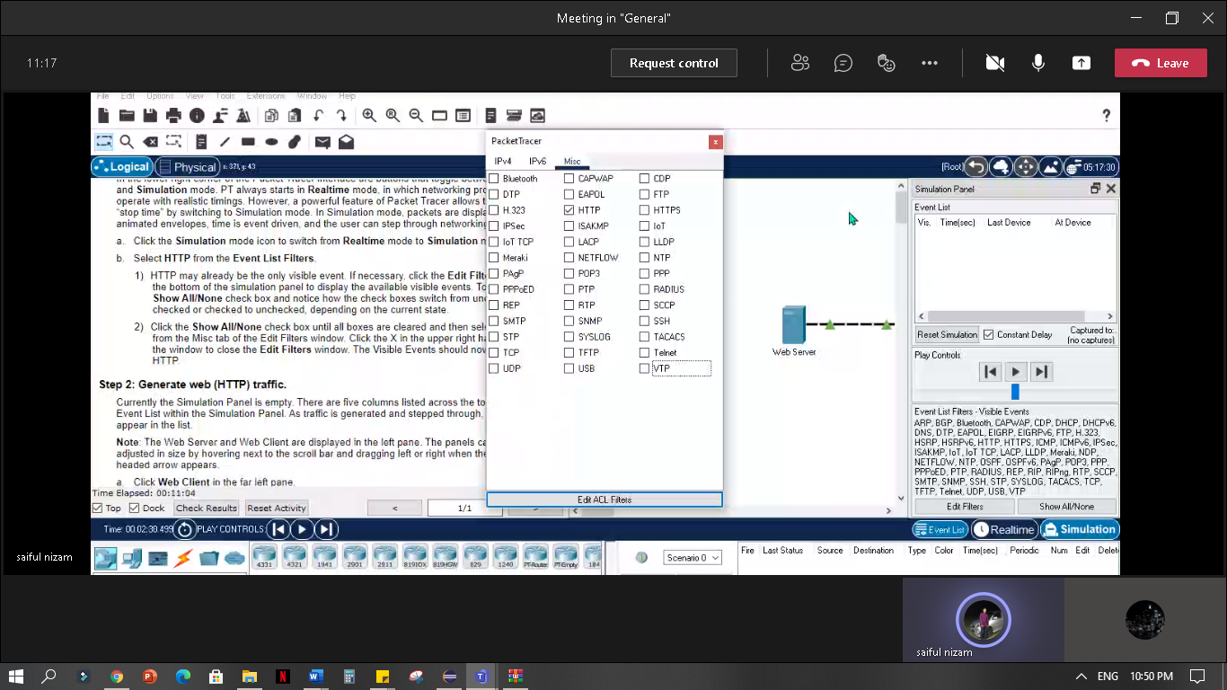

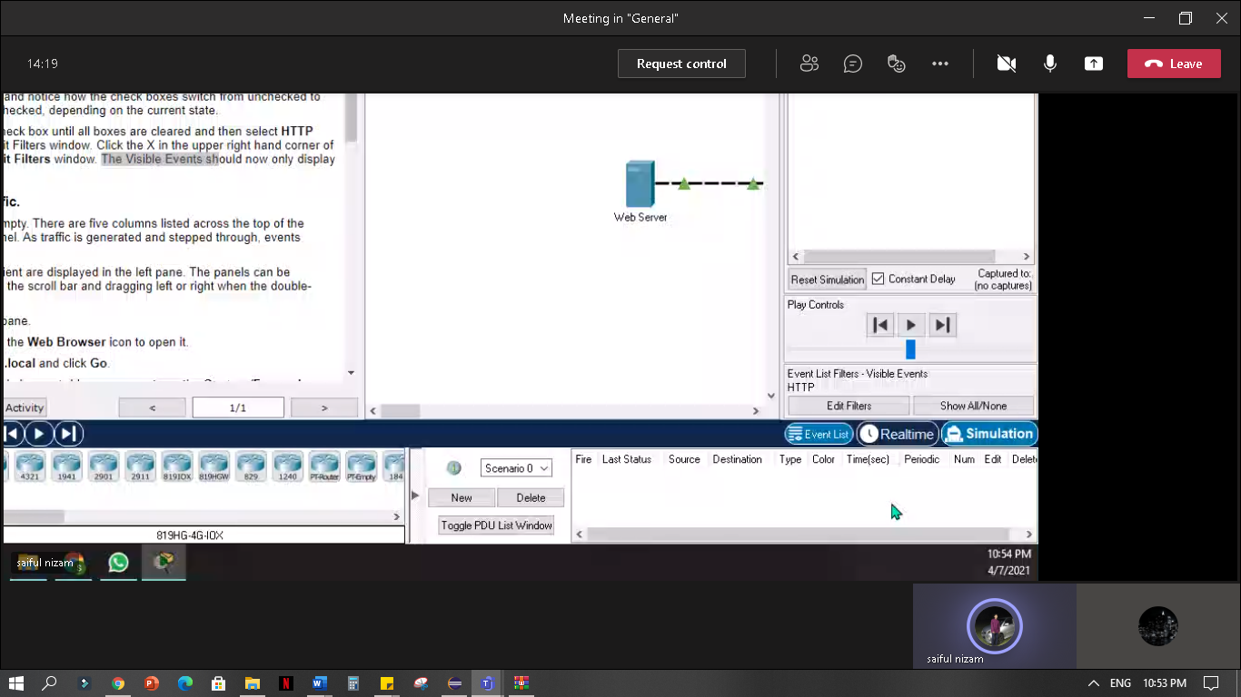

**Step 2: Generate web (HTTP) traffic.**

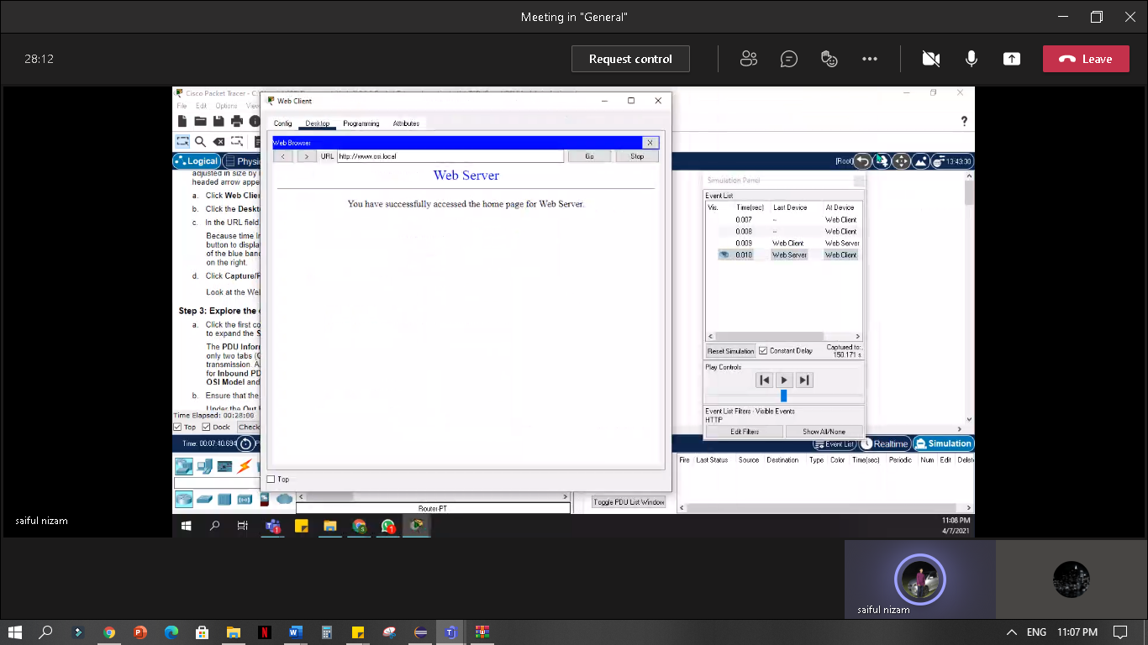

**Look at the Web Client web browser page. Did anything change?**

Answer: The web page was returned from the web server.

` **Step 3: Explore the contents of the HTTP packet.**

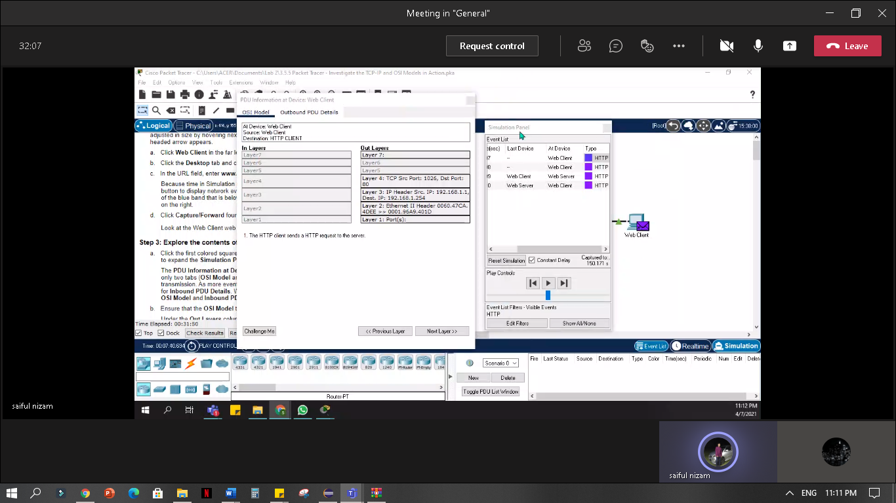 **a. PDU Information at Device: Web Client**

**b. What information is listed in the numbered steps directly below the In Layers and Out Layers boxes for Layer 7?**

Answer: The HTTP client sends a HTTP request to the servers

**What is the Dst Port value for Layer 4 under the Out Layers column?**

Answer: 80

**What is the Dest. IP value for Layer 3 under the Out Layers column?**

Answer: 192.168.1.254

**What information is displayed at Layer 2 under the Out Layers column?**

Answer: Ethernet II Header 0060.47CA.

4DEE >> 0001.96A9.401D

**c. What is the common information listed under the IP section of PDU Details as compared to the information listed under the OSI Model tab? With which layer is it associated?**

Answer: SRC IP and DST IP at Layer 3

**What is the common information listed under the TCP section of PDU Details, as compared to the information listed under the OSI Model tab, and with which layer is it associated?**

Answer: SOURCE PORT and DESTINATION PORT at Layer 4

**What is the Host listed under the HTTP section of the PDU Details? What layer would this information be associated with under the OSI Model tab?**

Answer: www.osi.local, Layer 7

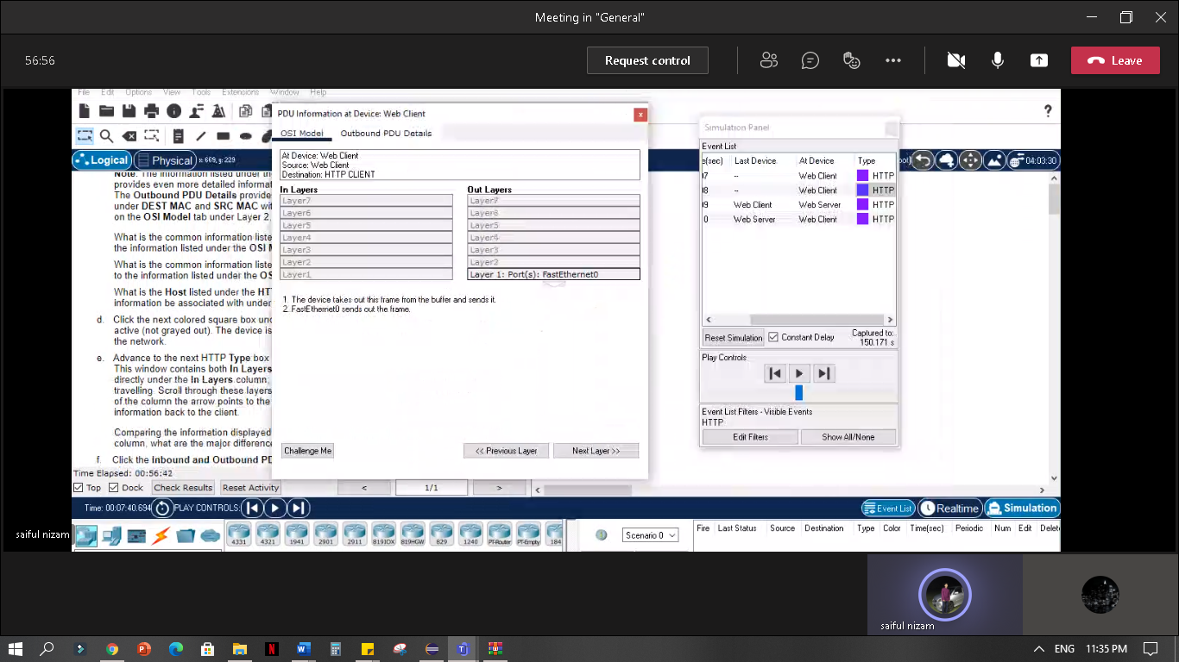

d.

**d. Comparing the information displayed in the In Layers column with that of the Out Layers column, what are the major differences?**

Answer: The Src and Dst Ports, Src and Dst IPs and MAC addresses have been swapped.

**g. How many tabs are displayed with this event? Explain.**

Answer: 2 tabs; OSI Model and Inbound PDU Details because these are the receiving devices.

**Part 2: Display Elements of the TCP/IP Protocol Suite**

**Step 1: View Additional Events**

**b. What additional Event Types are displayed?**

Answer: ARP, DNS, TCP, HTTP

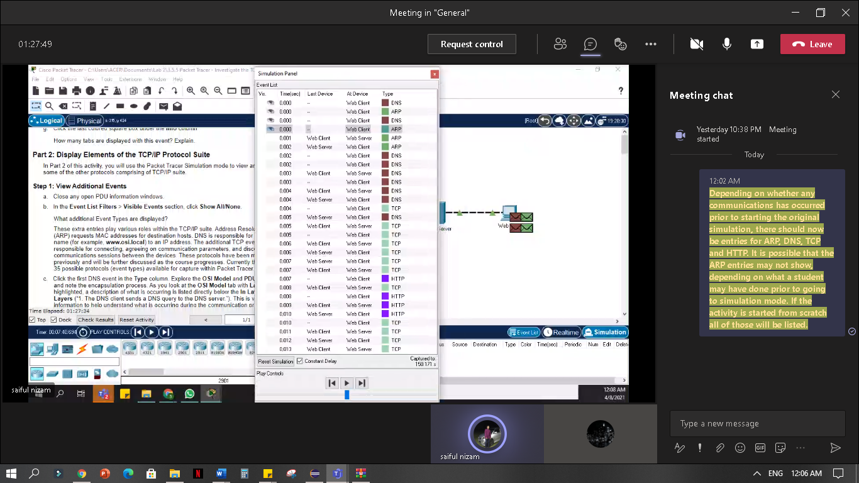

**d. Click the Outbound PDU Details tab.**

**What information is listed in the NAME field: in the DNS QUERY section?**

Answer: [www.osi.local](http://www.osi.local)

**e. Click the last DNS Info colored square box in the event list.**

**At which device was the PDU captured?**

Answer: The Web Client

**What is the value listed next to ADDRESS: in the DNS ANSWER section of the Inbound PDU Details?**

Answer: 192.168.1.254 – the address of the Web Server

**f. In the numbered list directly below the In Layers and Out Layers, what is the information displayed under items 4 and 5?**

Answer: 4. The TCP connection is successful.

5. The device sets the connection state to ESTABLISHED.

**g. What is the purpose of this event, based on the information provided in the last item in the list (should be item 4)?**

Answer: CLOSING the connection.

**Challenge Questions**

**Based on the information that was inspected during the Packet Tracer capture, what port number is the Web Server listening on for the web request?**

Answer: port 80

**What port is the Web Server listening on for a DNS request?**

Answer: port 53